**Dev Box setup**

Other than the specified edits marked with “!”, please go with the default installation checks and steps. You will need both backend and frontend installations to run the app locally.

**Back-end**

1.1 [Visul Studio Community 2022](https://visualstudio.microsoft.com/thank-you-downloading-visual-studio/?sku=Community&channel=Release&version=VS2022&source=VSLandingPage&cid=2030&passive=false) Installer (the download will start automatically by accessing the link)

## ! Ensure ASP.NET and web development package is checked

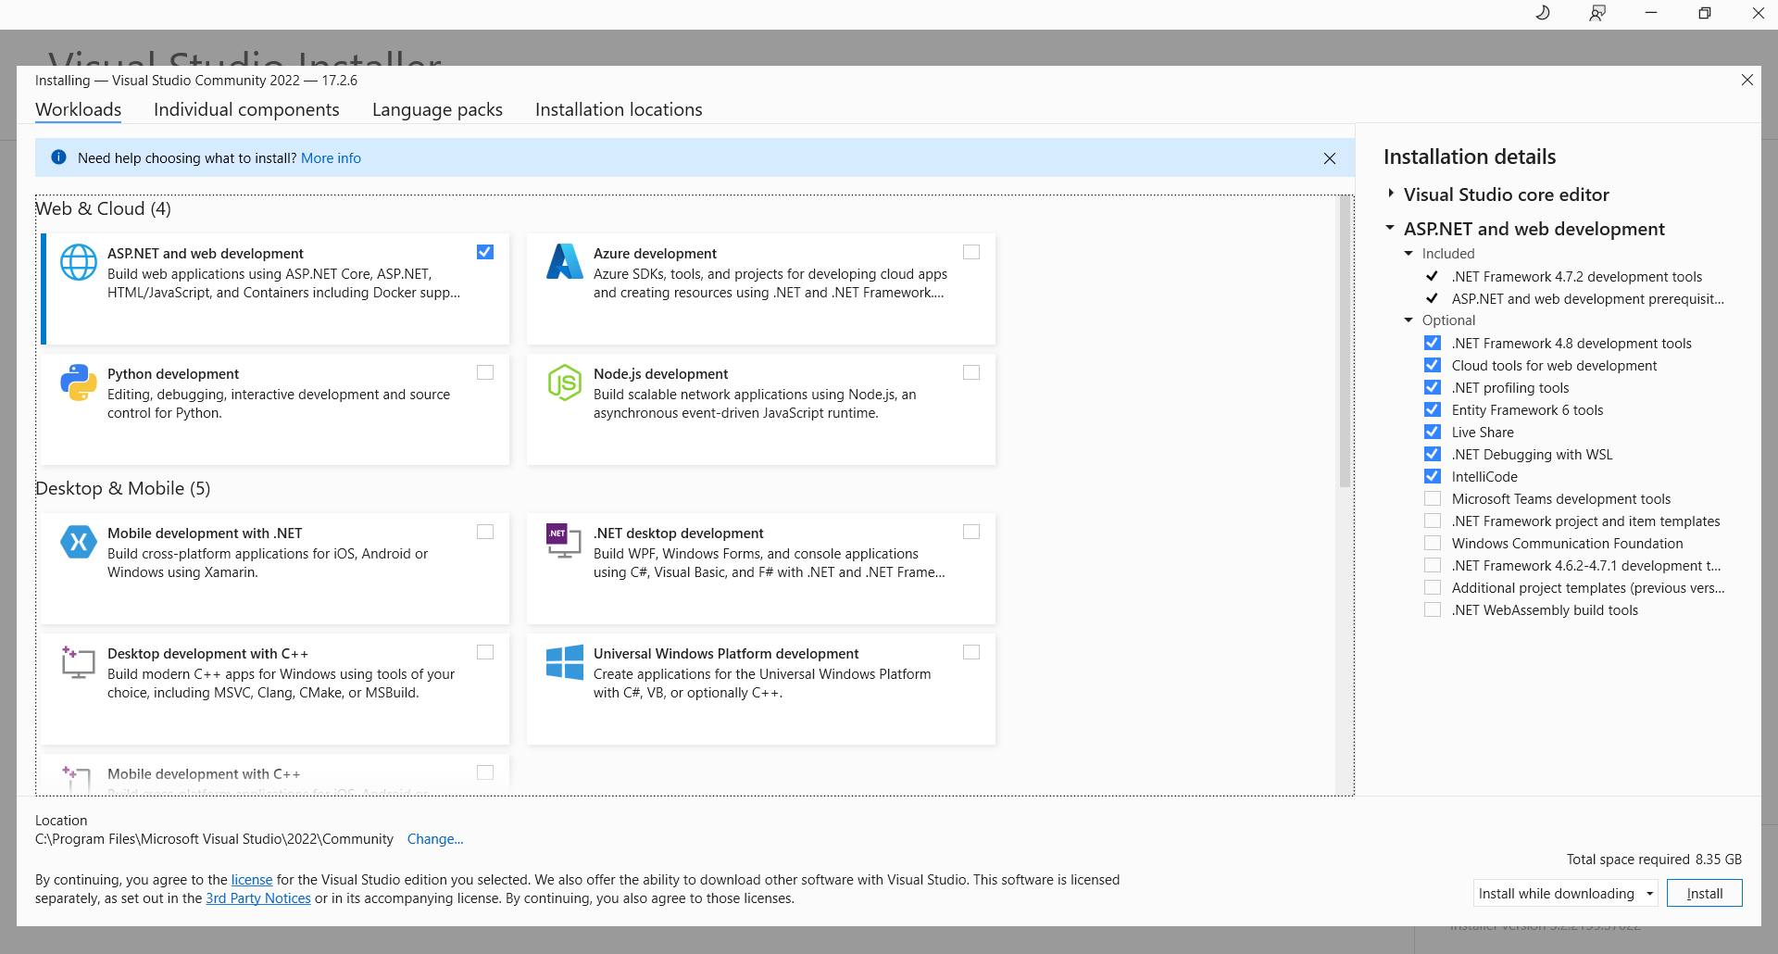

1.2 [SQL Server 2019](https://www.microsoft.com/en-us/sql-server/sql-server-downloads) – download the installer for the *Developer version* and select Basic installation !

1.3 When prompted with the successful installation modal, click on “Install SSMS”(SQL Server Management Studio) as well or go to [Download SQL Server Management Studio (SSMS) - SQL Server Management Studio (SSMS) | Microsoft Docs](https://docs.microsoft.com/en-us/sql/ssms/download-sql-server-management-studio-ssms?redirectedfrom=MSDN&view=sql-server-ver16) in order to get the SSMS installer ( “Free Download for SQL Server Management Studio (SSMS) 18.12.1” link on the page).

**Front-end**

2.1 [Visual Studio Code for Windows](https://code.visualstudio.com/)

2.2 [Node.js](https://nodejs.org/en/) LTS 16.16.0 version

! Check “automatically install the necessary tools” (a power shell window will show up, where you can see the extra tools installation progress)

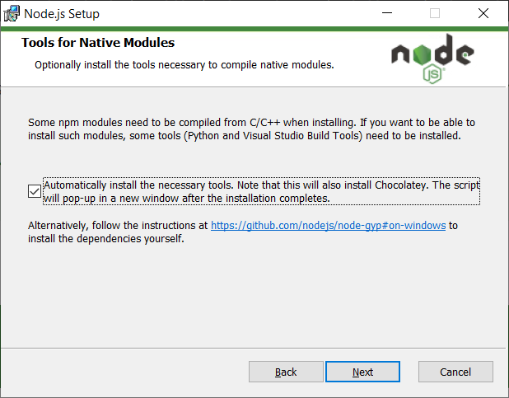

Note: You can check the installed versions by running *node -version* and *npm -version* in a console.

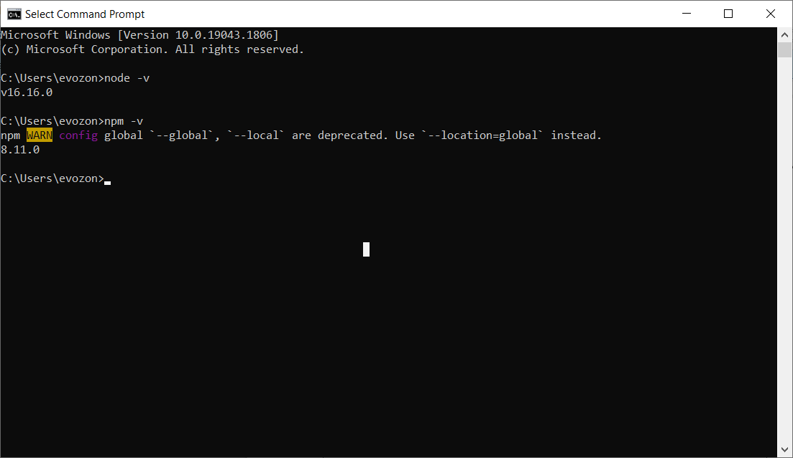

**Version Control**

3.1 [Notepad++ v8.4.2 x64 Installer](https://notepad-plus-plus.org/downloads/v8.4.2/)

3.2 [Git - Downloading Package (git-scm.com)](https://git-scm.com/download/win)

! Use Notepad++ as default editor instead of vim

3.3 [Kdiff3](https://sourceforge.net/projects/kdiff3/)

3.4 [Git Extensions](https://github.com/gitextensions/gitextensions/releases) (Download the msi file from here)

! After installation, when opened, you will be prompted with a settings checklist modal because there are some more configurations to be done

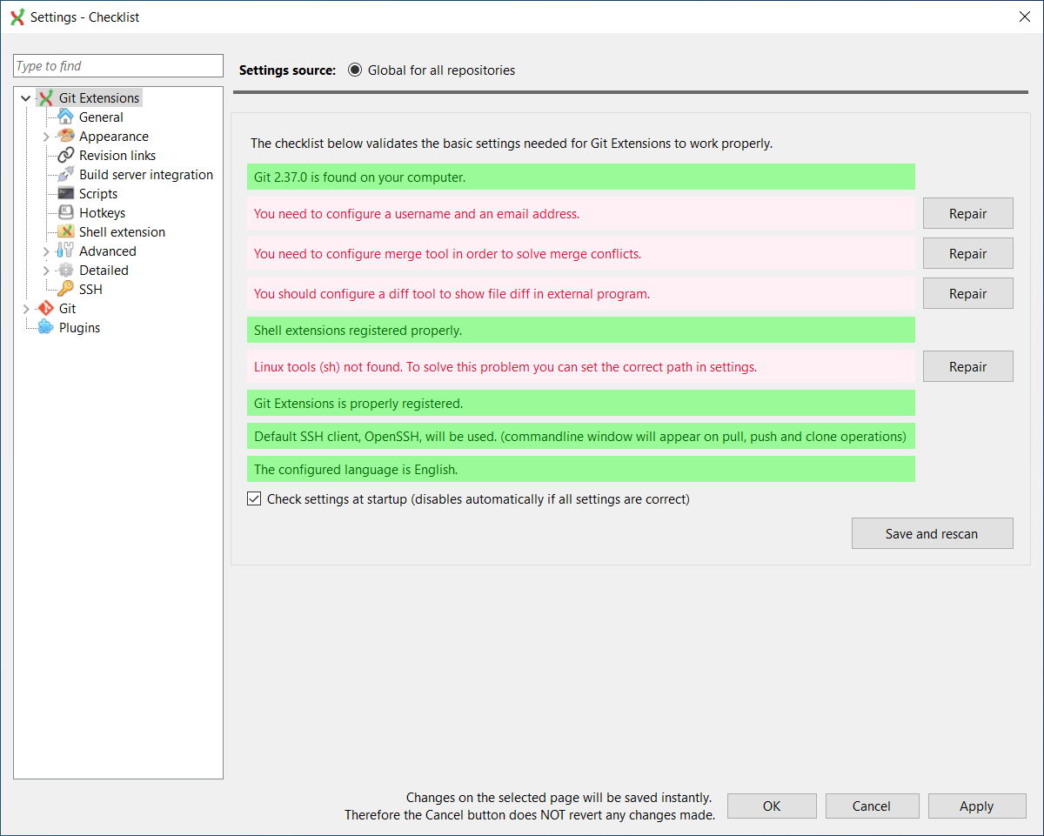

! Hit the first repair and type in the following:

- Your git username and email

- Select kdfiff3 as your mergetool, the path will be autocompleted

- Select kdfif3 as your difftool, the path will be autocompleted

- Select Windows-style line endings

Example:

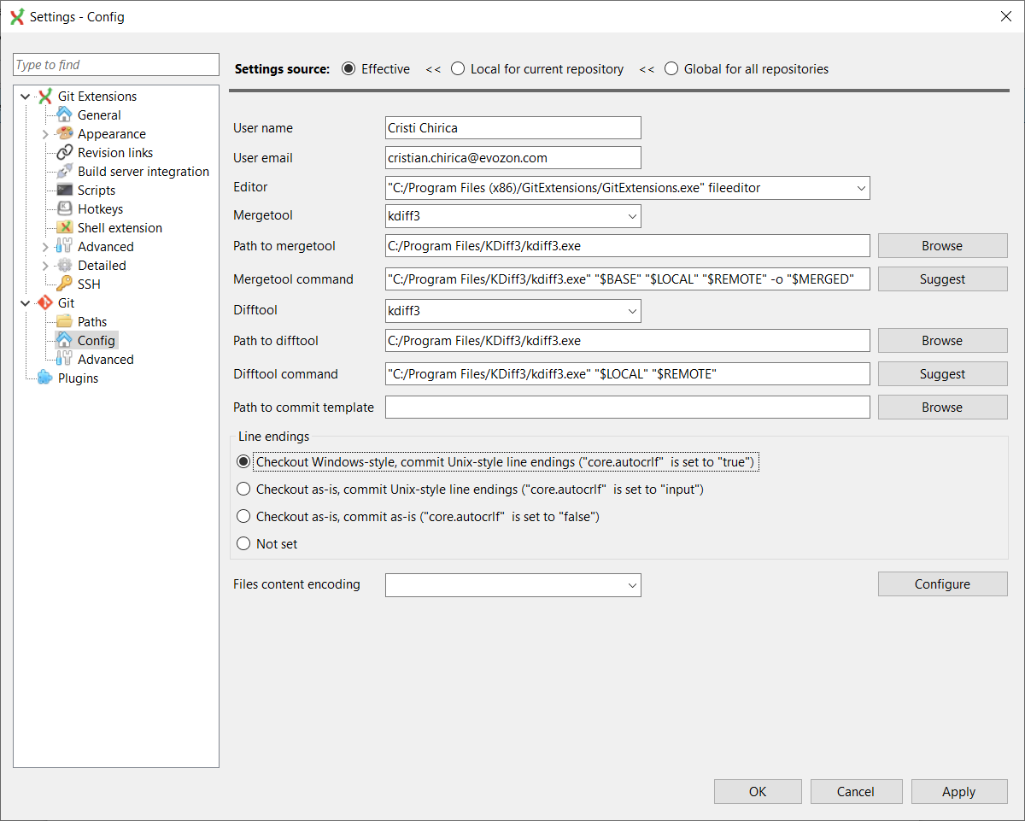

**Cloning the solution**

Create a new folder, you can call it EvoEvents.

Go to<https://tfs17.evozon.com/tfs/internship/2022-Team1/_git/BE>, click on clone and copy the https link.

Go to Git Extensions → Clone a repository, paste the copied https link and select the folder you created as

destination. After clicking clone, you will have to type your tfs account and password.

Now repeat the process for the front-end solution as well.

**Running the solution locally**

Open the back-end solution in Visual Studio.

To create the database:

- open Package Manager Console

- Select EvoEvents.Migrations as Default Project

- run Update-Database

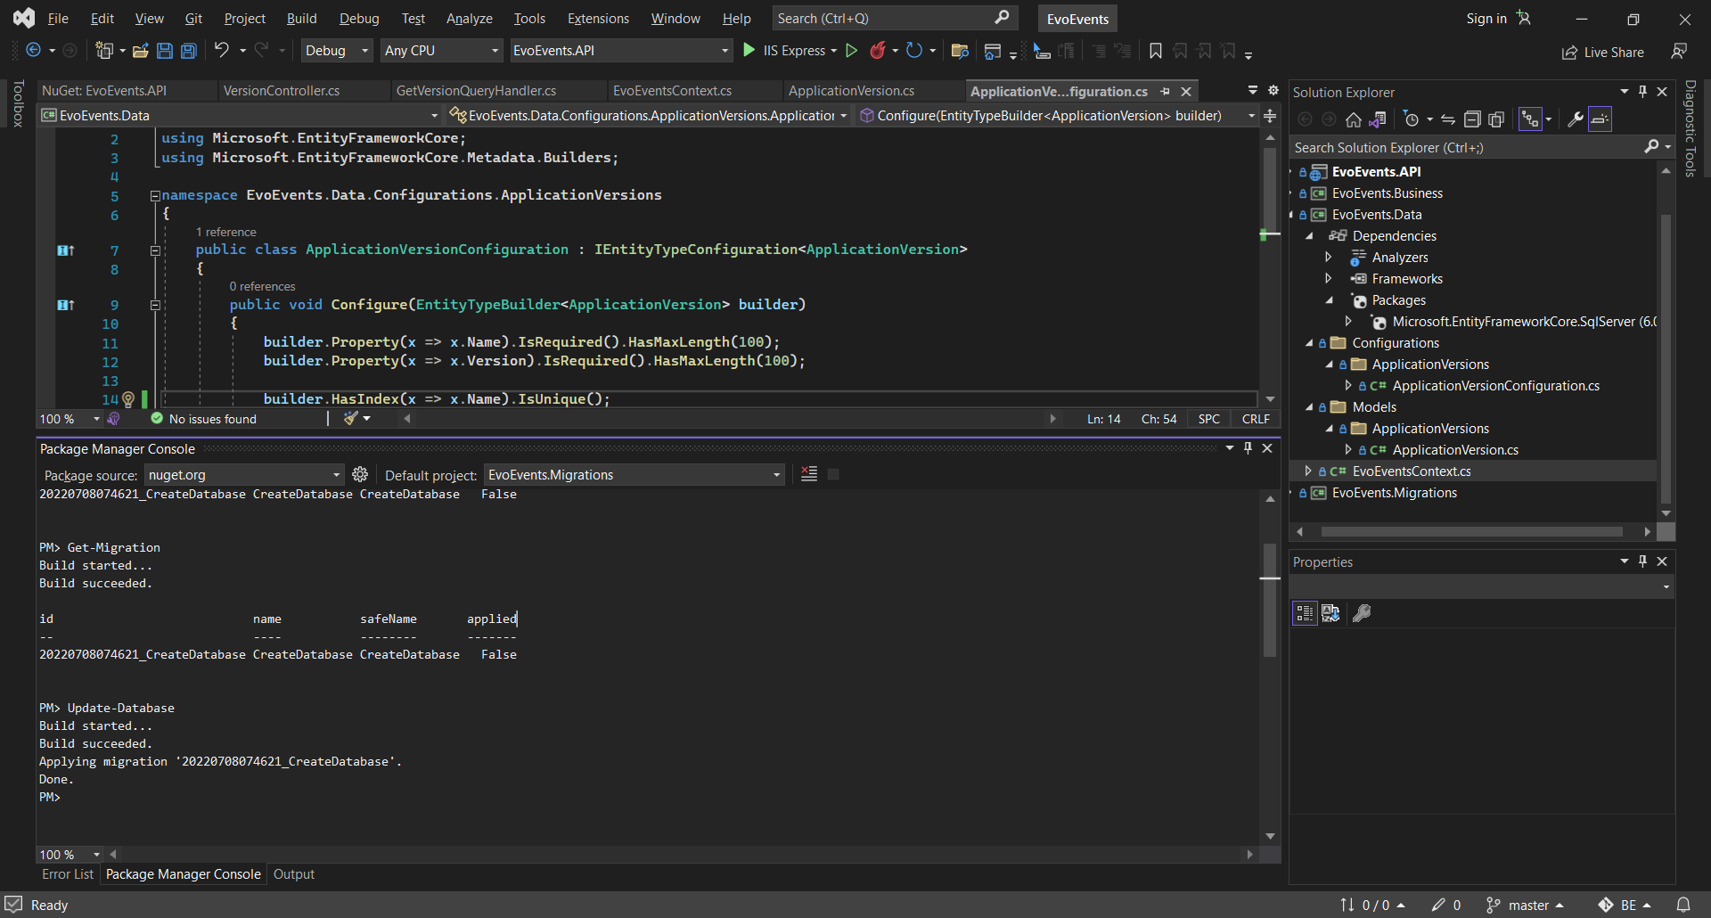

Run the app via n and allow ISS Express SSL certificate when prompted with the specific modal.

Open the front-end solution in Visual Studio Code and trust the authors when prompted with the specific modal.

Open a terminal is VS Code (Ctrl + Shift + ` or Terminal→New Terminal) and run the follwing commands:

*- npm install*

*- npm start*

*The app is now up and running and you’re rocking it already!*

[Postman](https://www.postman.com/downloads/)

*To manually test the api, run GET https://localhost:44315/api/version/get-version?name=Create%20Skeleton with SSL disabled.

**Other notes**

- Check if vpn is installed if working remotely. If not, a ticket to IT should be sent.

- For accessing the live environment, remote connect to 172.22.4.159 with TFS account.

- [Microsoft Teams](https://www.microsoft.com/ro-ro/microsoft-teams/download-app#desktopAppDownloadregion)